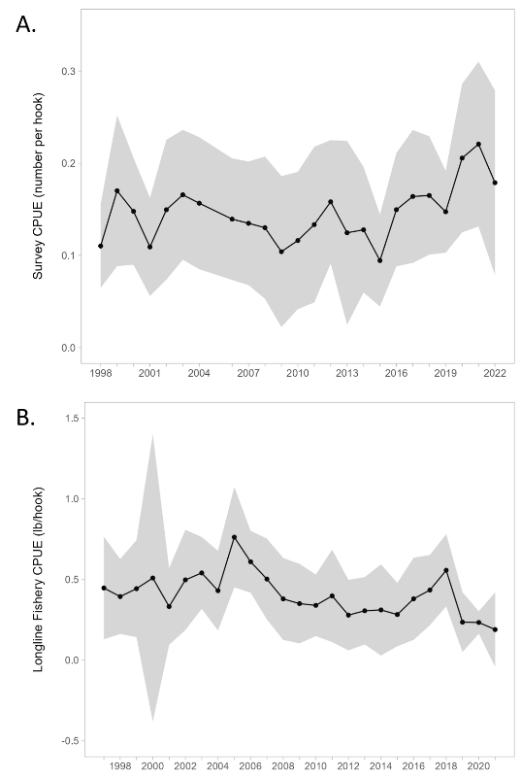

**Figure 3.1a.** Model predictions for the ADFG Northern Southeast Inside (NSEI) sablefish stock assessment (left panels; reproduced here with permission from Phil Joy, pers. comm., https://github.com/commfish/seak_sablefish) of age-2 recruitment (millions; top) and female spawning stock biomass (million pounds; bottom). Southern Southeast Inside (SSEI) sablefish longline survey catch-per-unit-effort (CPUE) in individuals per hook (right panel) from 1998 to 2022 (except 2005; reproduced here with permission from Ehresmann and Olson, 2022).

**Figure 3.1b.** Time series of total biomass, legal-sized biomass, sub-legal-sized biomass, and female spawning biomass (SSB) estimates for the British Columbia stock of sablefish based on weighted averages over the five OM scenarios used in 2022. Note that total, legal, and sub-legal biomass estimates include both female and male fish, while SSB is shown for only female Sablefish (reproduced here with permission from Kendra Holt, DFO Canada, pers. comm.).

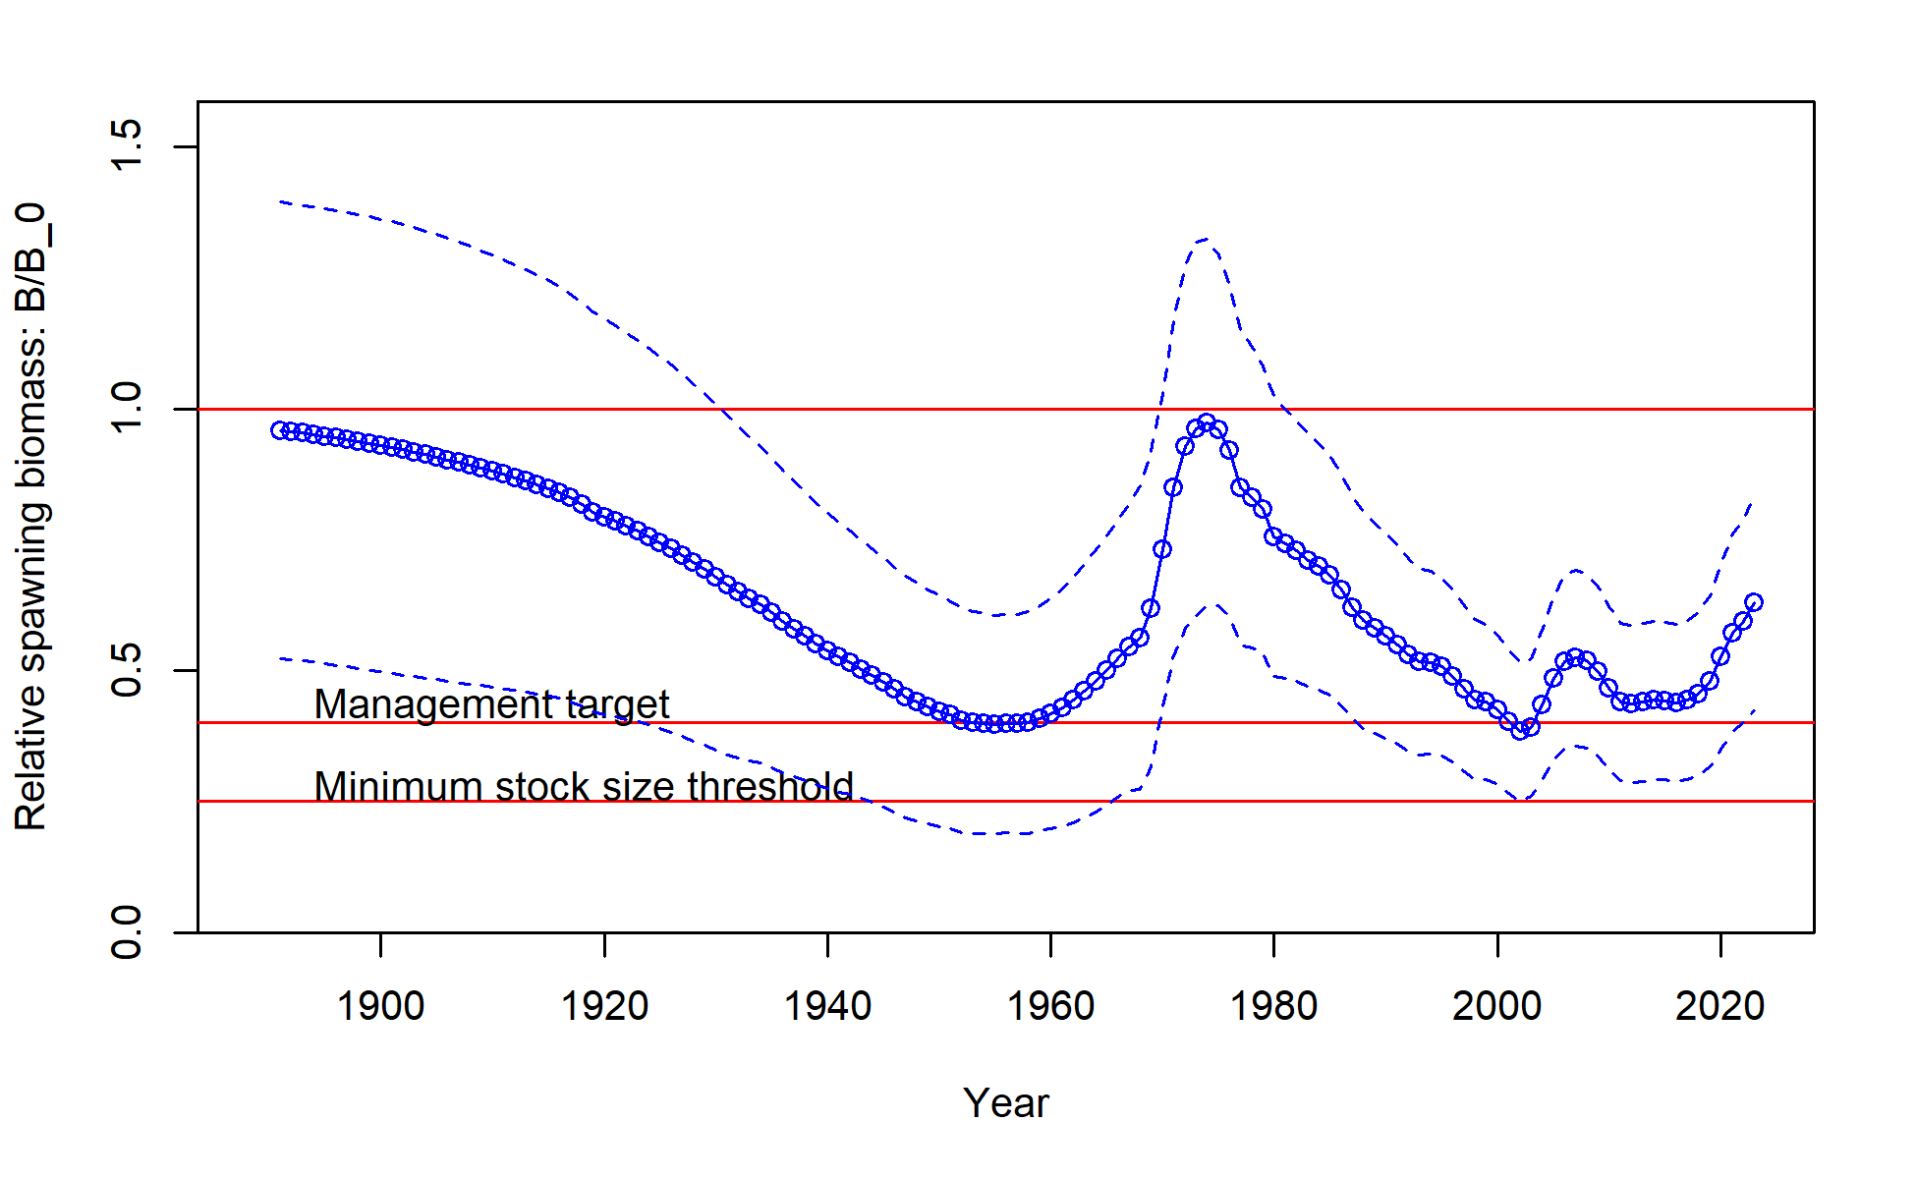

**Figure 3.1c.** Time series of total biomass relative to the unfished biomass for west coast USA sablefish (reproduced here with permission from Johnson et al. 2023).